* When the application goes into landscape mode, if we have custom layout designed for the landscape mode. It will go to that layout automatically.

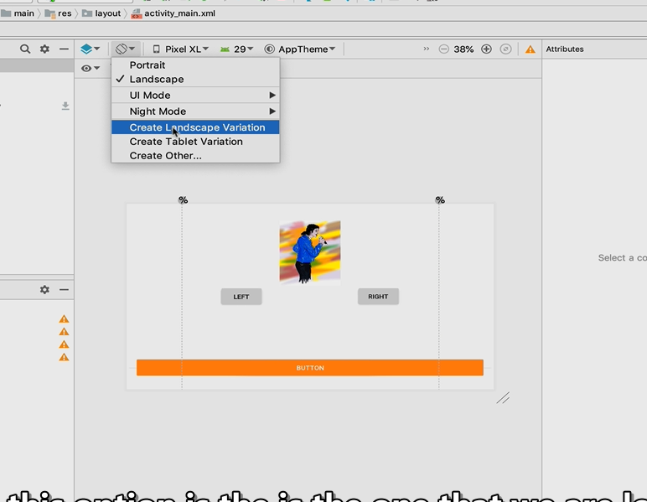

* We can create landscape variation from the above menu. Or we can go to create tablet version for tablet screen.
* Another option is to go to Res -> right click -> new -> android resource file. We can set resource type to layout and edit the available qualifier for customization.